Craftsbury Academy
Mr. Ethan Self
eself@ossu.org
802-586-2541
Course: AP Biology
Meeting Times: Mondays, Wednesdays, and alternating Fridays (8:00-9:45 AM)
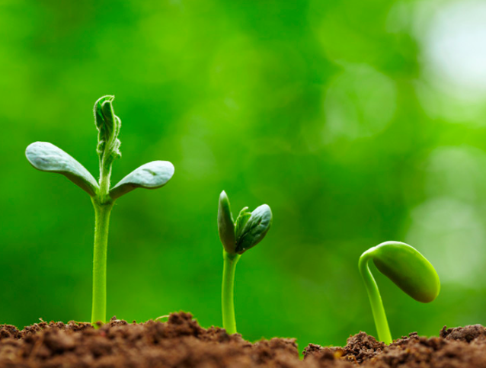
I hope that we will all stretch and expand our growing minds this year.

“Biology gives you a brain. Life turns it into a mind.”-Jeffery Eugenides

Course Descriptions:

Welcome to AP Biology! AP Biology is a college-level course offered to high school students across the nation, and even globally. This class is designed to challenge students with an in-depth examination of biology’s ‘big ideas’ while also honing in students’ critical thinking and scientific practices.

AP Biology will be primarily taught through the textbook ‘Campbell Biology in Focus’ 1st edition. The quantity of information can seem overwhelming, but the textbook does a good job at organizing specific chapters into broader ideas and units. We will be conducting experiments throughout the year to further expand our scientific knowledge, as well as working on scientific awareness, ethics, literacy, and writing. This will be a challenging and engaging class, but it will prepare you for your next step in life, whether it is college or a career!

Classroom Expectations:
- Selflessness. Help others, the school, and yourself whenever possible!
- Critical thinking. Don’t just absorb information!
- Investigate outside of the classroom.
- Engagement with your peers and community.
- Not afraid to take academic risks. Be prepared to learn new things!
- Creativity and curiosity!
- Empathy for others’ ideas and questions.

Course Expectations:
- Our classroom will thrive if you each contribute as active, engaged, and positive thinking students. Each day will be a new learning experience, whether it’s a laboratory, a research day, investigating new ideas, or more! I’ll do my best to have interesting topics, engaging learning activities, and independent choice for class, but I’m looking for you to bring your own ideas and thoughts into class.

- AP Biology is a college level course. The amount of material covered is immense and will take time and perseverance. You should expect to have 1-2 hours of homework between each class. I will assign 1-2 chapters out of the textbook over each weekend, for you to read, take broad notes, and outline. We will examine these chapters the following week with specific examples, learning activities, labs and more to further our knowledge.

- Completing homework on time will be very important in your success in the classroom! Many Monday classes will have you be an active learner and teacher to your peers. Not only should you have questions for your classmates, and me, but also spend time exploring current, related scientific ideas and facts. If you are ever unsure of an assignment, or need an alternative source to better understand something, please let me know.

- If you have any questions or concerns about an assignment outside of class, please email at a reasonable hour (before 9:00 PM). I expect you to communicate with me about any problem, concern, or question regarding an assignment either in person or via email.

- Although group work will be less in the class than in other science classrooms, group work is quite possibly the most important skill each of us can work on (even me!). We will have group projects, laboratories, and e simple classroom exercises where you will be expected to be a positive, engaged learner with all of your peers. I don’t expect all of you to be best friends with one another, but I do expect that your respect each others’ ideas and contributions, while also pushing each other to create the best possible learning environment.

- Finally, I want our classroom to be a fun, exciting place to learn! Science should be about examining our world, our selves, and our community. I would love your input and ideas to help me develop projects and learning experiences where we use the outdoors and classroom as a place to think creatively, critically, and have fun doing it!

Grading:
Semester grades will be determined on a point system (0-100). However, Craftsbury is transitioning towards a proficiency-based grade system. This means that all of your assignments will have clear learning objectives and skills, and that you will also be assessed on your learning habits. Most of our learning targets will be self-directed by the Urry Biology textbook.
- Homework: 5% (graded for completion and effort, including class participation. This will often take shape as reading notes over the weekends, outlining papers/websites, and other formative means of learning).

- Reading Quizzes: 5% (A formative measure to see how well you read and understood the assigned chapters from homework, as well as reinforcing practice in deciphering AP-level multiple choice questions).

- Summative Assessments: 30% (Throughout the year we will take many chapter/unit tests which practice deciphering AP-level multiple choice questions as well as writing concise, clear, and critical (the 3 C’s) short response questions. This also might be any other assignment that extends and furthers classroom learning).

- Labs and Projects and Other: 20% (we will use electronic means to record data, write and compose lab write ups, and more for easier organization)

- Learning Habits: 40% (this grade is designed to help each of you become better learners. We will periodically assess our strengths and weaknesses as learners and classroom members, and set goals throughout the year. Also measured on classroom engagement and respect).

Other Tid-Bits:
- Late work policy: Any assignment turned in late will not impact the grade attached to the assignment. However, late assignments must be handed in with a late-assignment sheet, as well as a conversation with Mr. Self about a plan to prevent future late assignments. I am flexible and understand that many things come up in life, but deadlines are important for making sure we are successful learners.
  - Any work not handed in will be recorded as a ‘0’ in powerschool. However, when the assignment is handed in, it will solely be graded on the academic work.
  - Late assignments however will significantly impact your learning habits score (40% of your grade)!
  - Assignments must be completed 1 week after the end of the unit (I will be very vocal about deadlines) or the grade will be marked a 0 after the unit ends.

- Organization is a great way to reduce wasted time and improve your grades. A three ring binder (or labeled segment in one) is necessary to keep track of handouts and assignments. A notebook for outlining and taking notes on chapters would be encouraged, although making an electronic version could be effective. Extra copies of handouts will be available in the classroom and on the class website.

- If you are absent, always please check schoology for assignments. I will gladly help you successfully learn missed learning activities, but I’m not simply looking for you to ask me what assignments were missed. Be proactive and accountable!

- Beyond schoology, I will have a website with information regarding major assignments, resources for additional learning, a day-day agenda with attached documents, and more! I will also have a blog about exciting things in our classroom (for parents and community members) that will be written by you and me (we can compile and share your projects and labs!). There will be accumulating information regarding the AP Biology exam as well!
  - http://craftsburyscience.weebly.com

- I am new to Craftsbury and am looking forward to becoming part of your community! Please let me know about things going on in the town and beyond! I’m also looking to start several clubs/organizations at school (running, photography, food science, environmental outdoor clubl?), so let me know your thoughts on what Craftsbury’s next steps should be throughout the year!

Let’s have a wonderful and exciting year full of learning,

Ethan Self

Please tear off the following page and fill it out with a parent or guardian. Return it to Mr. Self as your first homework assignment by September 5th.

Students and families, after reading the above information please answer the following questions.

- What is your full name? ____________________________________

- Do you prefer to be called by a different name in class? ________________________

- What’s the coolest/most unique place that you’ve ever visited?

- How do you best learn new information or ideas? What challenges you when learning new things?

- What has challenged you before in a science classroom? What have you enjoyed in a science classroom?

- Are you aware of the time requirements for the AP exam? What concerns do you have before taking this class?

- If a school garden was established next year, how excited would be to learn about gardening and agricultural science? Would you want to use the vegetables in the school cafeteria?

- Additionally, what would your interest be in developing an outdoor club at Craftsbury, where students and teachers did outdoor recreation and natural sciences?

For Parents To Answer:

- Will your student have computer access at home? Internet?

- What is the best way for me to contact you? Phone? Email?

- What are some of your son or daughter’s strengths or weaknesses that would help me make their learning more successful?

- What methods of learning or learning strategies have helped your son or daughter in the past (in any classes)? Which haven’t helped?

- What helps motivate your son or daughter to do well in school, or to strive to understand/apply anything she or he learns?

- How well does your son or daughter handle frustration/adversity/difficulty in the classroom? Is there something I can do make sure they are both appropriately challenged but also successful in their learning?

- Do you have any personal, work-related, or other connections to the science community (I’m looking to help collaborate in and out of the classroom for projects and learning opportunities)?

- Do you have any questions, comments, or concerns, especially regarding the AP exam or the amount of work required in the class?

Please print and sign your name below to show that you have read and understood this information, and answered the above questions.

Student name: _____________________________________________

Student signature ___________________________________________

Parent / Guardian name: ______________________________________

Parent / Guardian signature: ___________________________________

